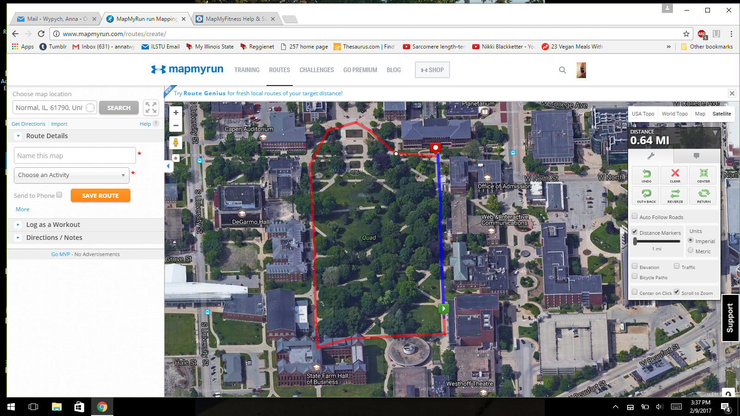

Not sure how to crop this but once around the quad is about .65 miles! Twice around gives you a mile and a third, 1.3 miles. Three times around about 2 miles!
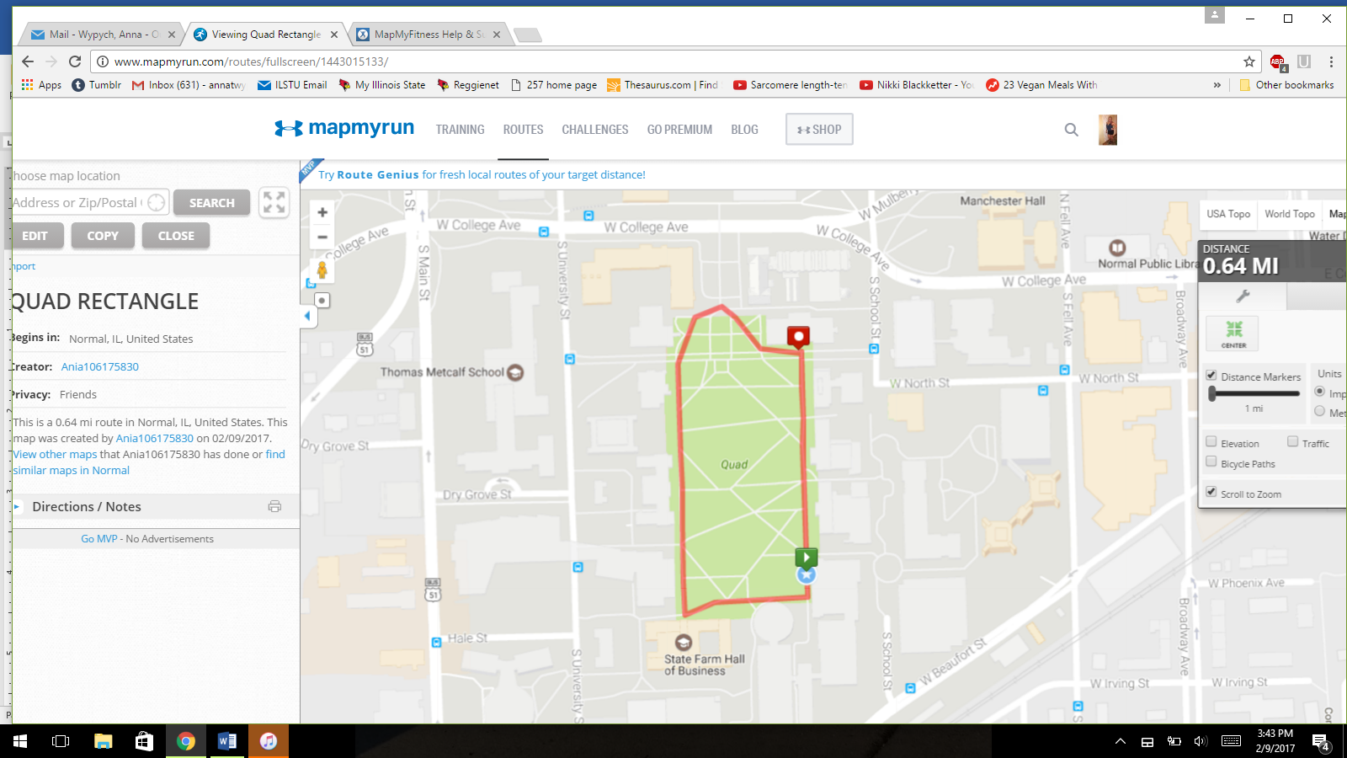
Same route but in map view

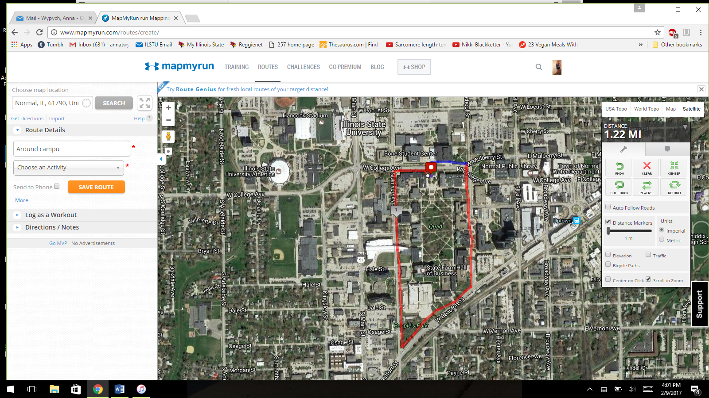
Around campus , starting in front of Schroeder, crossing the bridge towards Milner, turning right before Milner, downward slope towards Mulberry and College intersection, turn right going southward on School St, right on Beaufort, right on university, right on college, and end in front of Schroeder .
Essentially: College Ave, School St., Beaufort St. University St.
This route is 1.22 miles, so twice around is nearly 2.5 miles!
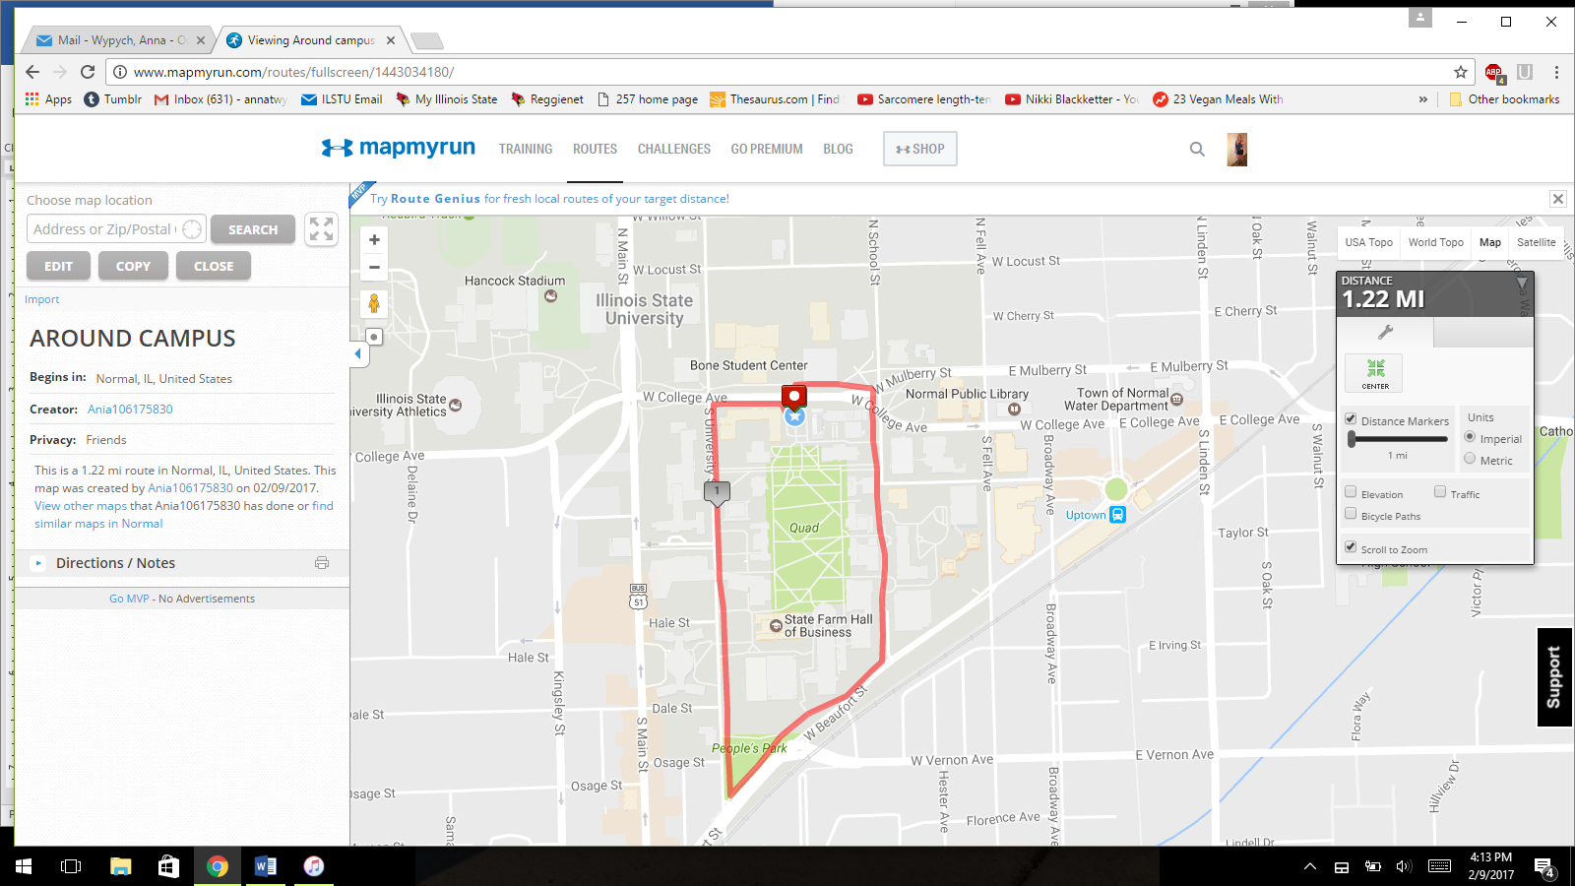
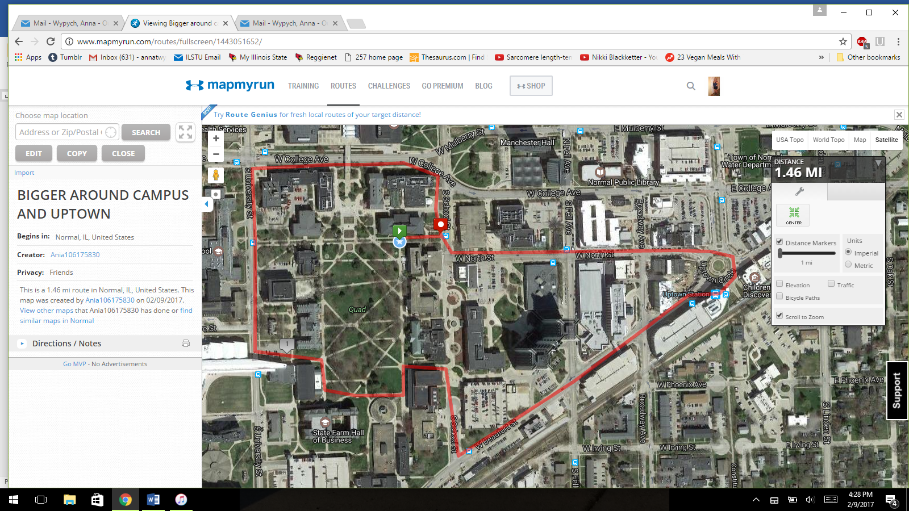

Biggest route, includes uptown! Total is 1.5 miles!

